**Exp No.3**

**Rishab Mandal**

**Batch: C23**

**Code:**

activity_main.xml

<?xml version="1.0" encoding="utf-8"?>  
<LinearLayout  
 xmlns:android="http://schemas.android.com/apk/res/android"  
 xmlns:tools="http://schemas.android.com/tools"  
 android:layout_width="match_parent"  
 android:layout_height="match_parent"  
 android:orientation="vertical"  
 android:padding="16dp"  
 tools:context=".MainActivity">

<TextView  
 android:id="@+id/textView"  
 android:layout_width="wrap_content"  
 android:layout_height="wrap_content"  
 android:text="C23\nRishab Mandal\nRoll no: 2103110"  
 android:textSize="20sp"  
 android:textColor="@android:color/black"  
 android:layout_centerHorizontal="true"  
 android:layout_margin="50dp"/>

<TextView  
 android:layout_width="wrap_content"  
 android:layout_height="wrap_content"  
 android:text="Name:"/>  
 <EditText  
 android:id="@+id/editTextName"  
 android:layout_width="match_parent"  
 android:layout_height="wrap_content"  
 android:hint="Enter your name"/>  
 <TextView  
 android:layout_width="wrap_content"  
 android:layout_height="wrap_content"  
 android:text="Email:"/>  
 <EditText  
 android:id="@+id/editTextEmail"  
 android:layout_width="match_parent"  
 android:layout_height="wrap_content"  
 android:inputType="textEmailAddress"  
 android:hint="Enter your email"/>  
 <RadioGroup  
 android:id="@+id/radioGroupGender"  
 android:layout_width="match_parent"  
 android:layout_height="wrap_content"  
 android:orientation="horizontal">  
 <RadioButton  
 android:id="@+id/radioButtonMale"  
 android:layout_width="wrap_content"  
 android:layout_height="wrap_content"  
 android:text="Male"/>  
 <RadioButton  
 android:id="@+id/radioButtonFemale"  
 android:layout_width="wrap_content"  
 android:layout_height="wrap_content"  
 android:text="Female"/>  
 </RadioGroup>  
 <CheckBox  
 android:id="@+id/checkBoxAgree"  
 android:layout_width="wrap_content"  
 android:layout_height="wrap_content"  
 android:text="I agree to the terms and conditions"/>  
 <Button  
 android:id="@+id/buttonSubmit"  
 android:layout_width="match_parent"  
 android:layout_height="wrap_content"  
 android:text="Submit"/>  
  
</LinearLayout>

MainActivity.java

package com.example.formapplication**;**import android.os.Bundle**;**import android.view.View**;**import android.widget.Button**;**import android.widget.CheckBox**;**import android.widget.EditText**;**import android.widget.RadioButton**;**import android.widget.RadioGroup**;**import android.widget.Toast**;**import androidx.appcompat.app.AppCompatActivity**;**public class MainActivity extends AppCompatActivity {  
  
 private EditText editTextName**,** editTextEmail**;** private RadioGroup radioGroupGender**;** private CheckBox checkBoxAgree**;** private Button buttonSubmit**;** @Override  
 protected void onCreate(Bundle savedInstanceState) {  
 super.onCreate(savedInstanceState)**;** setContentView(R.layout.*activity_main*)**;** // Initialize views  
 editTextName = findViewById(R.id.*editTextName*)**;** editTextEmail = findViewById(R.id.*editTextEmail*)**;** radioGroupGender = findViewById(R.id.*radioGroupGender*)**;** checkBoxAgree = findViewById(R.id.*checkBoxAgree*)**;** buttonSubmit = findViewById(R.id.*buttonSubmit*)**;** // Set click listener for the submit button  
 buttonSubmit.setOnClickListener(new View.OnClickListener() {  
 @Override  
 public void onClick(View view) {  
 // Get user input  
 String name = editTextName.getText().toString().trim()**;** String email = editTextEmail.getText().toString().trim()**;** int genderId = radioGroupGender.getCheckedRadioButtonId()**;** boolean agreeToTerms = checkBoxAgree.isChecked()**;** // Validate input  
 if (name.isEmpty() || email.isEmpty() || genderId == -**1** || !agreeToTerms) {  
 Toast.*makeText*(MainActivity.this**,** "Please fill in all fields and agree to terms"**,** Toast.*LENGTH_SHORT*).show()**;** } else {  
 // Display a toast with the form data  
 String gender = (genderId == R.id.*radioButtonMale*) ? "Male" : "Female"**;** String message = "Name: " + name + "\nEmail: " + email + "\nGender: " + gender + "\nAgree to terms: " + agreeToTerms**;** Toast.*makeText*(MainActivity.this**,** message**,** Toast.*LENGTH_LONG*).show()**;** }  
 }  
 })**;** }  
}

**Output:**

Opening and filing the form

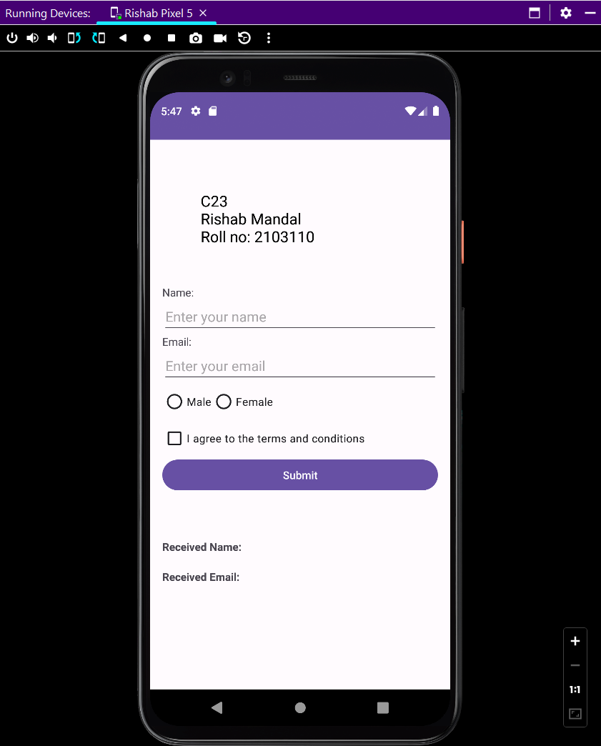

Filled form, clicking on submit button



